**THINGS TO LOOK FOR WHEN YOU VISIT NIMROD’S CASTLE**

* **The Baibars inscription** – near the western gate, inside the fortress, is the largest and most imposing inscription ever found in Israel to date. Four lines, engraved on a stone six meters long, glorify the Sultan Baibars, in whose period the main part of the present fortress was constructed, other commanders and the date: 674 after the Hegira (1275 AD).
* **The south-western tower** – an enormous 4-story tower that was expanded during the Mameluke period (1250 to 1517 AD). The tower is of great importance because it defended the relatively vulnerable southern side. The tower is a wonderful lookout point to the whole southern wall.
* **The large cistern** – northeast of the south-western tower there is a large cistern into which rainwater flowed via a now-ruined system of channels.  
  The drinking fountain is located on the external wall at the southern side of the reservoir.
* **The “Beautiful Tower”** – a very impressive seven-sided building. Due to its size, a clustered column was built at its center, from which the arches of the roof spread out to the walls of the building. The carving of the stones is on a very high standard.
* **The moat** – a channel carved out of the rock, separating the fortress from its keep. The purpose of the moat was to protect the keep from enemy attack.
* **The keep** – on the highest point in the castle is the keep, built as an independent fortress, with its own moat and wall. It provided a line of defense should the lower part of the castle be captured. There is a spectacular view from the top of the keep. It is well worth the walk.
* **The northern tower** – an imposing tower at the western end of the northern wall, built in 1230 AD. The well-preserved tower includes a hall with arrow slits in its walls, from which a staircase can be climbed to the roof. In the 15th century AD, the place apparently served as a prison.
* **The western gate** – the stones of the arch over the gate moved in the earthquake that occurred in 1759 AD.
* **The secret passage** – alongside the gate there is a large opening leading to a beautiful staircase leading to a secret passage, through which it is possible to leave the fortress without being discovered by the enemy outside.
* **The cistern** – outside the fortress, on its eastern side, there is a water cistern measuring 85X177 feet, and 16 feet deep. Its location on a slope enabled the collection of rainwater that served the inhabitants of the castle.

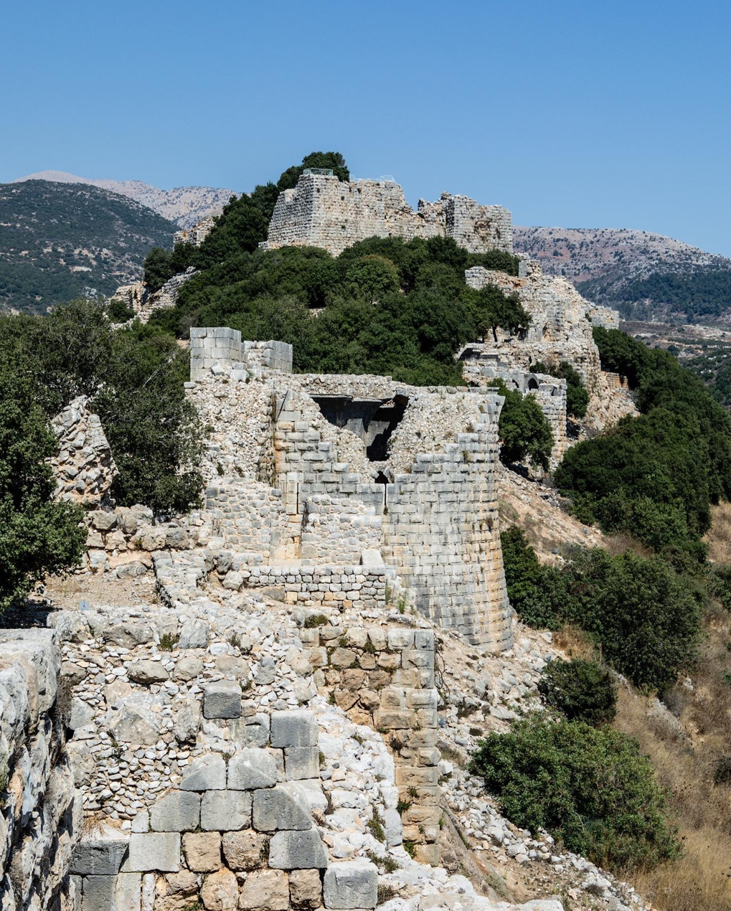

**Photo Credit: Amanda Sites, 2022**